Jacob Dineen

IST659 DB Admin Lab #9

9/10/2017

## Step 1 – Create Some Data.

---------- LAB 9 SOLO ADVENTURE ----------

CREATE TABLE Lab9 (

Lab9ID int identity primary key

, Lab9Text char(30) not null

, EnteredBy char(30) not null

)

GO

Create View PartnerLab9 AS

Select * FROM Lab9 WHERE EnteredBy = 'Partner'

GO

Create Procedure AddPartnerLab9 (@Lab9Text char(30)) AS

Begin

Insert into Lab9 (Lab9Text, EnteredBy) Values (@Lab9text, 'Partner')

END

GO

Create View MyLab9 AS

Select * from Lab9 WHERE EnteredBy = 'ME'

GO

CREATE Procedure AddMyLab9 (@Lab9Text char(30)) AS

BEGIN

INSERT INTO Lab9 (Lab9Text, EnteredBy) VALUES (@Lab9Text, 'Me')

END

GO

EXEC AddMyLab9 'First Value'

Exec AddMyLab9 'Second Value'

EXEC AddMyLab9 'Third Value'

EXEC AddMyLab9 'Fourth Value'

Select * FROM MyLab9

Select * From Lab9

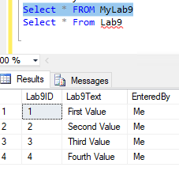

## Step 2 – Connect as a Guest and do some things.

-- Replace IST659_Labs with your database name

USE IST659_M400_jdineen

Select * from PartnerLab9

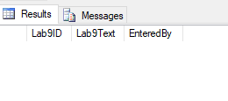

EXEC AddPartnerLab9 'First Value'

Exec AddPartnerLab9 'Second Value'

EXEC AddPartnerLab9 'Third Value'

EXEC AddPartnerLab9 'Fourth Value'

Select * from PartnerLab9

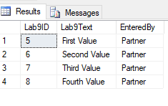

DELETE Lab9 where EnteredBy = 'Partner'

This did not work in the guestuser script because the guest user does not have the permission to run the select or delete on the Lab9 table.

Revoke Select on PartnerLab9 to guestuser

Revoke Execute on AddPartnerLab9 to guestuser

In your answer doc, answer the following questions:

1. What does the CREATE USER statement do? Hint: It’s not creating a user….

The CREATE USER statement adds a user to the current database. In this instance, guestuser is already an existing user, and we are granting access to the specific view that we have created for them.

1. Which types of objects are securable with GRANT and DENY statements? (Research required. )

Grant and Deny statements can be used on objects such as databases, tables, views, stored procedures, and functions.

1. Describe a scenario by which you would not want a user reading the table directly but rather using a view instead.

In my project, I am actually dealing with customer passwords and customer credit card information (hypothetical numbers, but still). In this instance, we may want views created that prevent that information from being directly visible for consumption in order to protect our customers.

1. Describe a scenario by which you would not want a user updating data in the table directly but rather using a stored procedure instead?

I actually had some experience with stored procedures when I was 17 working in an adtech agency – I was responsible, in part, for some ETL work on points of interest across the United States, and we would update existing records with google map locations. We would also update the scorecards for advertising campaigns. To stop us, with our limited knowledge, from accidentally deleting records, or making a mistake in mass, we were given rights to stored procedures.

1. Write SQL to deny the guest user permissions to delete from a table called Product

Deny Delete on Product to guestuser

1. Write SQL to allow the guest user the ability to run one of your SQL Views. Place your sql here and the message returned when executed.

Grant Select on Product to guestuser

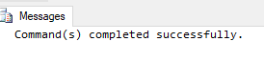

Unsure if 6 is related to my personal project – if so, that code would be:

GO

CREATE View AllAppCredentials As

Select

FirstName

,LastName

, Application.ApplicationName

, AppCredentials.UserName as AppUserName

,AppCredentials.Password as AppPassword

From Account

Left Join UserInfo on UserInfo.UserID=Account.UserInfo_UserID

Join Application on Application.Account_AccountID= Account.AccountID

Join AppCredentials on AppCredentials.Application_ApplicationID=Application.ApplicationID

Grant Select on AllAppCredentials to guestuser